**ARTIFICIAL INTELLIGENCE**

**CREATE A CHATBOT USING PYTHON**

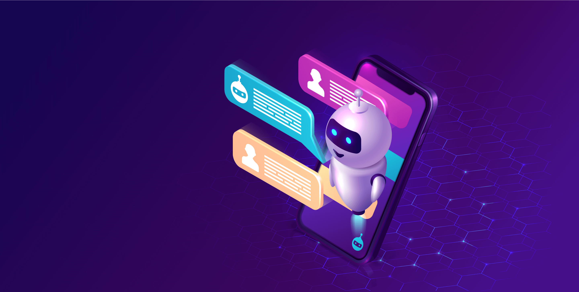

Name: Kalavathy K

Reg. No: 513521104019

Department: CSE

Year: III

NM ID: au513521104019

Emailid: [kaviyakalavathy@gmail.com](mailto:kaviyakalavathy@gmail.com)

Phase 5

**PROBLEM STATEMENT:**

Develop a chatbot using Python that can effectively engage with users, provide helpful information, and perform tasks or answer questions across various domains. The chatbot should be able to understand natural language input and provide appropriate responses, ensuring a smooth and user-friendly conversational experience.

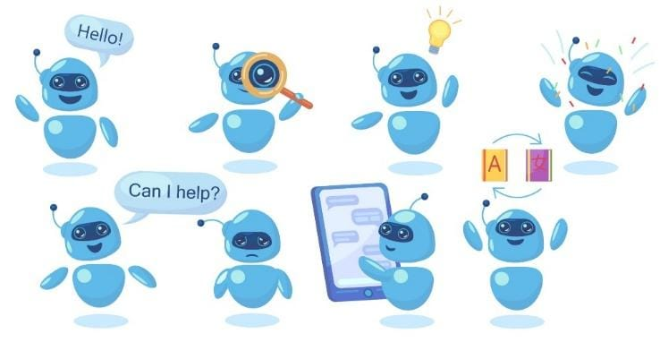

**PROJECT OVERVIEW:**

1. Natural Language Understanding: Implement natural language processing (NLP) techniques to enable the chatbot to understand and interpret user input effectively. This includes intent recognition, entity extraction, and context awareness.
2. Multi-Domain Support: Design the chatbot to handle a wide range of user queries across different domains, such as customer support, general knowledge, e-commerce, and more.
3. Personalization: Incorporate features that allow the chatbot to remember user preferences and maintain context throughout the conversation, providing a personalized user experience.
4. Task Automation: Enable the chatbot to perform tasks or actions on behalf of users, including making recommendations, scheduling appointments, or processing orders.
5. Integration: Integrate the chatbot with external data sources, APIs, or databases to fetch real-time information or execute specific actions. This may involve accessing weather data, retrieving product details, or connecting to booking systems.

**THE TEAM MEMBERS:**

1. Karpagapriya R (Team lead) - 513521104020
2. Mubeena E.M - 513521104028
3. Yuvashree E - 513521104060
4. Kalavathy K - 513521104019

**INTRODUCTION:**

"Welcome to the world of Chatbot development with Python! In this project, we embark on a journey to create an intelligent and interactive chatbot powered by Python's Natural Language Processing (NLP) capabilities. Our goal is to design a chatbot that can engage in meaningful conversations, answer questions, and provide assistance across a range of domains. Through data acquisition, model training, and iterative improvement, we aim to craft a chatbot that not only understands user queries but also offers contextually relevant responses. Join us as we explore the fascinating realm of conversational AI and create a chatbot that's ready to assist and engage with users."

**DESIGN THINKING**

Design thinking is a human-centered approach to problem-solving and innovation. When designing a chatbot using Python, applying design thinking principles can help create a user-centric and effective conversational AI system.

Here's a design thinking process tailored for developing a chatbot using Python:

1. Empathize
2. Define
3. Ideate
4. Data Preprocessing
5. Text cleaning
6. Tokenization
7. Prototype
8. Train model
9. Test(Visualize metrics)
10. Implement(Inference model)
11. Deploy
12. Model evaluation

By following this design thinking process, you can develop a chatbot using Python that not only meets user needs but also evolves over time to provide an increasingly valuable conversational experience. The iterative nature of design thinking ensures that the chatbot remains relevant and effective in a dynamic environment.

**PROBLEM DEFINTION**:

Chatbots in customer support comes with interpreting the messages and understanding the user intention. Programming flexible algorithms for interpreting the intention of the message is a top priority upon making a chatbot.

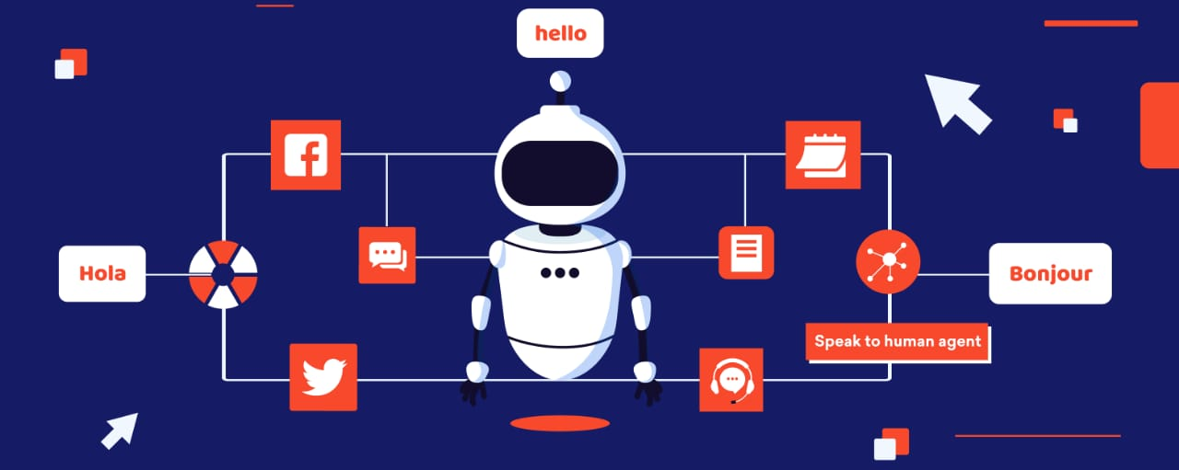

1. Empathize: Understand User Needs

User Research: Begin by conducting in-depth user research to understand the needs, pain points, and preferences of your target audience. Gather feedback through surveys, interviews, and user observations.

User Personas: Create user personas to represent different user segments, each with unique characteristics and requirements for the chatbot.

2. Define: Clearly Define the Problem

Problem Statement: Based on the insights gained during the empathize phase, define a clear problem statement that the chatbot will address. Consider what specific tasks or issues the chatbot will help users with.

3. Ideate: Brainstorm Solutions

Cross-Functional Team: Assemble a cross-functional team that includes developers, designers, NLP specialists, and domain experts to brainstorm creative solutions.

4. Prototype: Build a Minimum Viable Product (MVP)

Develop MVP: Create a basic version of the chatbot using Python. Focus on core functionalities that address the defined problem. Use Python libraries or frameworks suitable for chatbot development.

5. Test: Gather Feedback

Usability Testing: Conduct usability testing with real users to gather feedback on the chatbot's functionality, user interface, and overall user experience.

6. Implement: Develop the Chatbot

Programming: Develop the chatbot using Python and relevant libraries or frameworks. Implement natural language understanding (NLU) and natural language generation (NLG) components for effective communication.

7. Deploy: Make the Chatbot Accessible

Hosting: Deploy the chatbot to a hosting environment that ensures availability and scalability. Consider cloud-based hosting solutions.

1. **EMPATHIZE**

Understanding user needs is a critical aspect of designing and developing a chatbot that is effective and user-friendly. Developers should consider the following key user needs:

**Clear Communication:** Users need a chatbot that communicates clearly and in a language they understand. The chatbot should avoid jargon and complex terminology, providing responses that are easy to follow.

**Efficiency**: Users value efficiency in their interactions with a chatbot. They expect quick and accurate responses to their queries or requests. Developers should prioritize minimizing response times and streamlining interactions.

**Relevance**: Users want the chatbot to provide information or assistance that is relevant to their needs or context. Developers should ensure that the chatbot's responses and actions are tailored to individual users when possible.

**Problem** **Solving**: Users often turn to chatbots to solve problems or complete tasks. Developers should design the chatbot to be capable of addressing common user issues and helping users accomplish their goals.

**Personalization**: Personalization is increasingly important to users. Developers can enhance user experience by allowing chatbots to remember user preferences, past interactions, and other relevant information to deliver a more personalized experience.

**User**-**Friendly** **Interface**: The chatbot's user interface should be intuitive and user-friendly. Users need to be able to navigate the chatbot easily and understand how to use it without confusion.

**Privacy** **and** **Security**: Users are concerned about their data and privacy. Developers must implement robust security measures to protect user information and communicate transparently about data handling practices.

**Availability**: Users expect chatbots to be available when needed. Ensure the chatbot is accessible 24/7 if possible, or communicate its operating hours clearly to users.

**Error** **Handling**: Users appreciate a chatbot that can gracefully handle errors and unexpected inputs. Developers should design the chatbot to respond appropriately when it encounters user mistakes or misunderstandings.

**Feedback** **and** **Help**: Users should have the ability to provide feedback on the chatbot's performance or request assistance when needed. Developers can implement mechanisms for users to report issues or seek human assistance when the chatbot cannot provide a solution.

Accessibility, Consistency, MultilingualSupport, Integration, Simplicity, Empathy, Quality Content etc are some of the user needs in development of chatbot.

By comprehensively understanding these user needs, developers can create chatbots that not only meet user expectations but also provide valuable and satisfying interactions. Regular user feedback and testing are essential to continuously refine the chatbot based on evolving user needs.

**2.DEFINE**:

"The problem to be solved is that users need an efficient and user-friendly way to schedule appointments with healthcare providers. Existing scheduling systems are often cumbersome, require phone calls, and are prone to errors, leading to patient frustration and missed appointments. The chatbot's objective is to streamline the appointment scheduling process, provide real-time availability information, and send timely reminders to both patients and healthcare providers, ultimately improving the patient experience and reducing appointment no-shows."This problem statement is clear and specific. It identifies the users' pain points (inefficient scheduling, missed appointments), the limitations of the current system, and the chatbot's role in addressing these issues (streamlining scheduling, real-time information, reminders). It also aligns with the user needs and objectives, making it a robust foundation for the chatbot's design and development.

**3.Importing Libraries:**

In this step we will import all the required libraries and packages from the pre-installed modules.

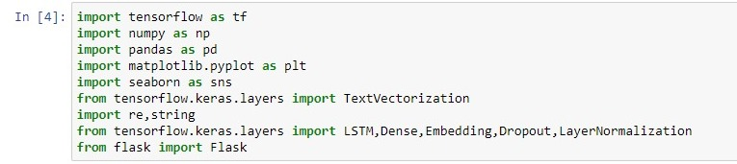

**4.Loading datasets:**

In this step we will be loading the chatbots datasets acquired from Kaggle.

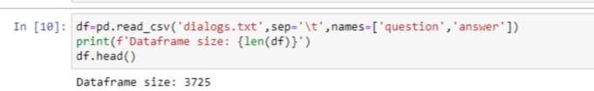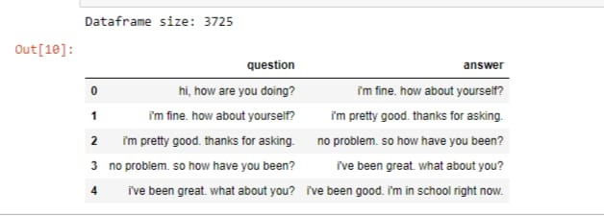

**5. Ideate**:

**Data Preprocessing: (Data Visualization)**

We will be pre-processing the data for the further development of model.

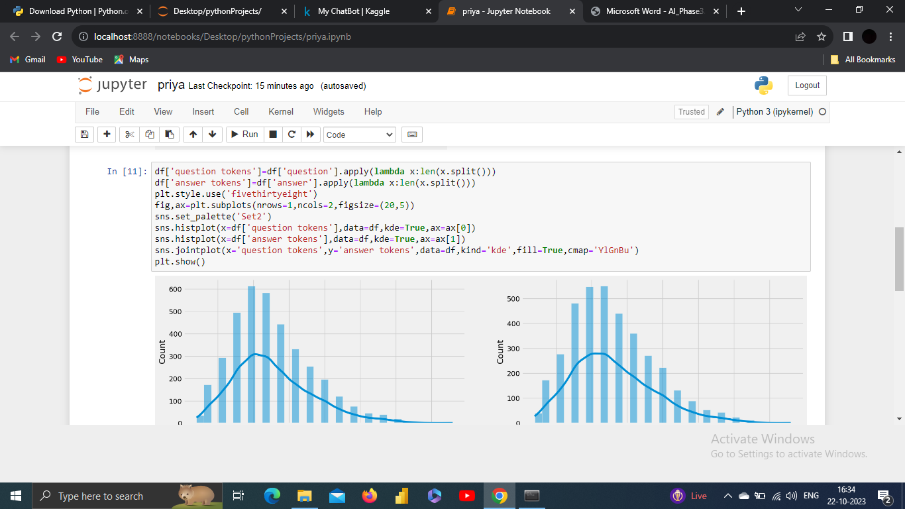

**O/P:**

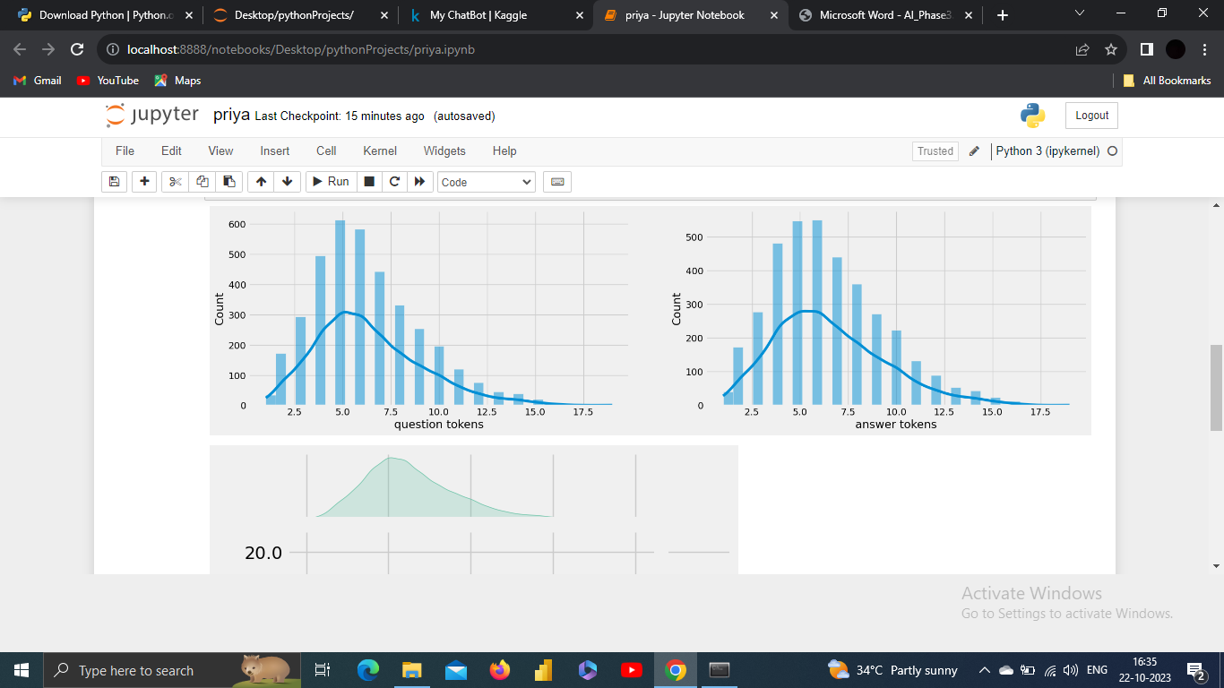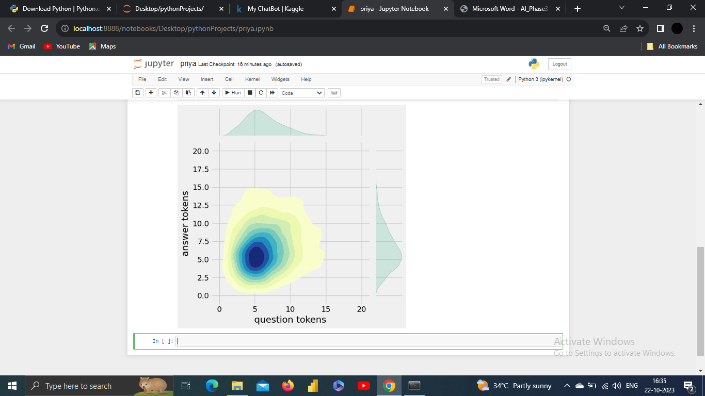

**6.Text** **Cleaning**:

Text cleaning, also known as text preprocessing, is the process of preparing and standardizing textual data to make it suitable for analysis or natural language processing (NLP) tasks. This process involves several steps to remove or transform elements in text data that can hinder accurate analysis or modeling.

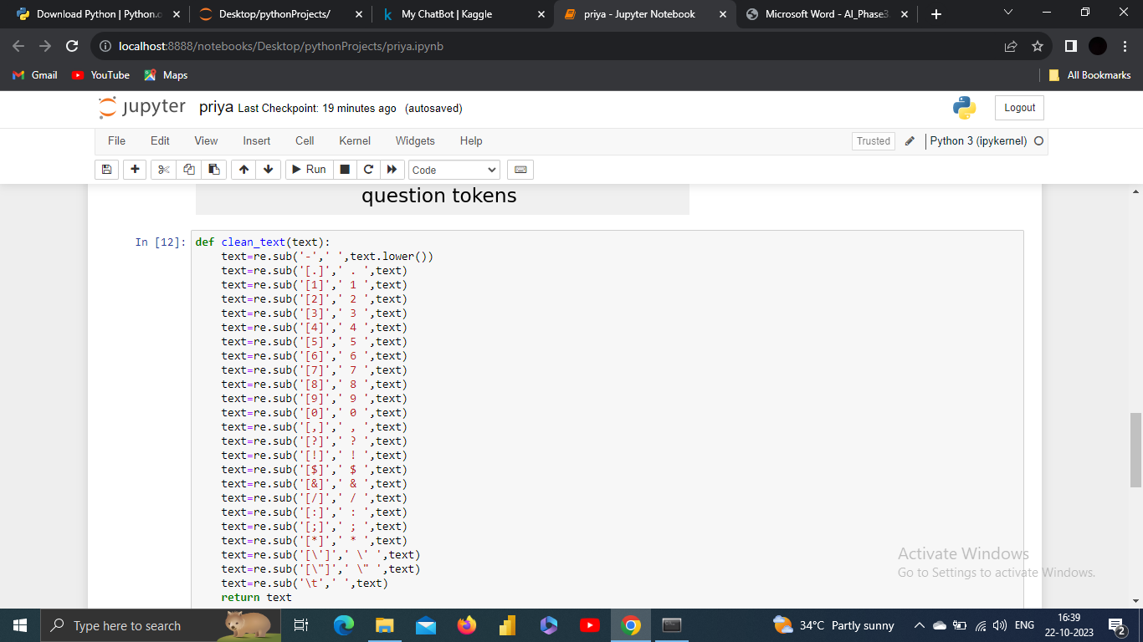

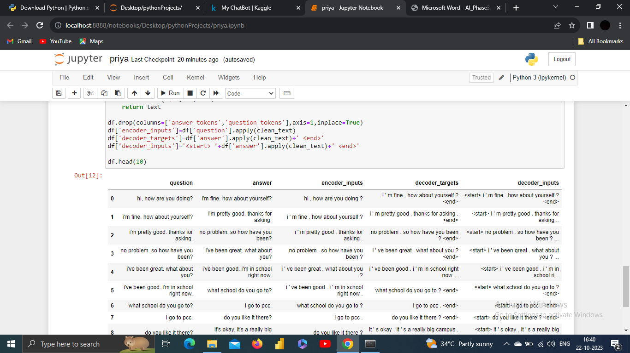

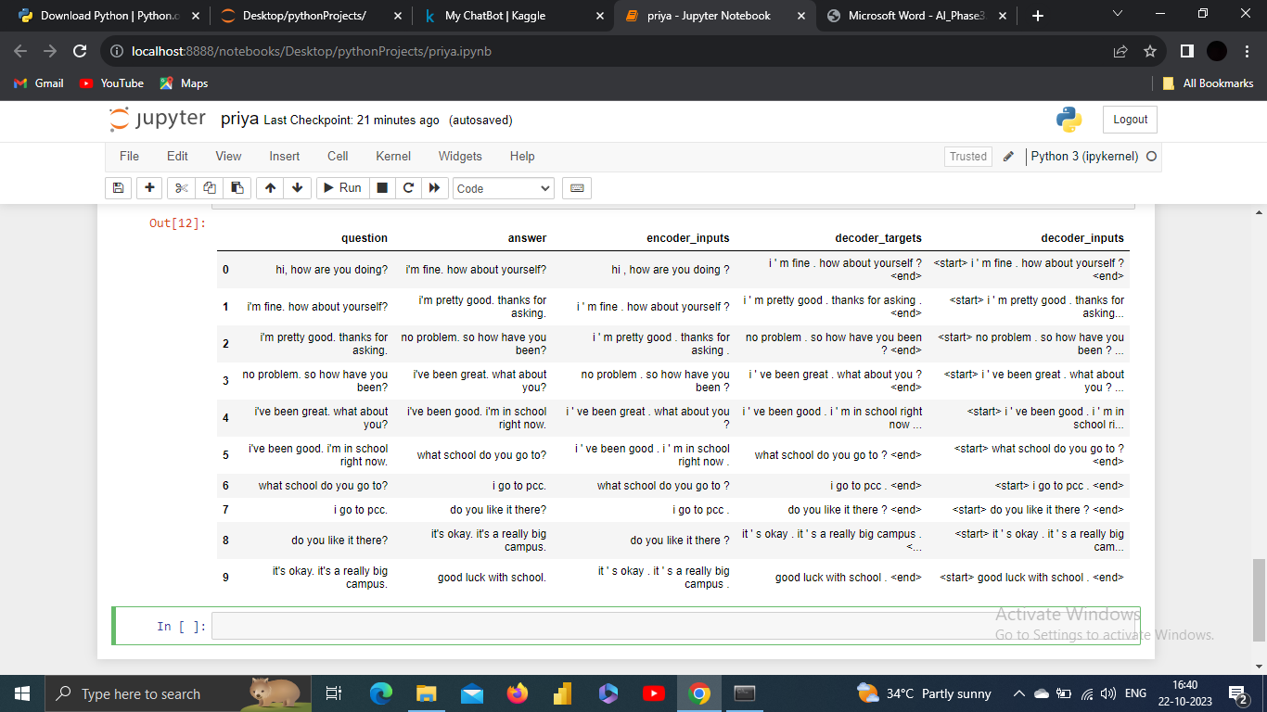

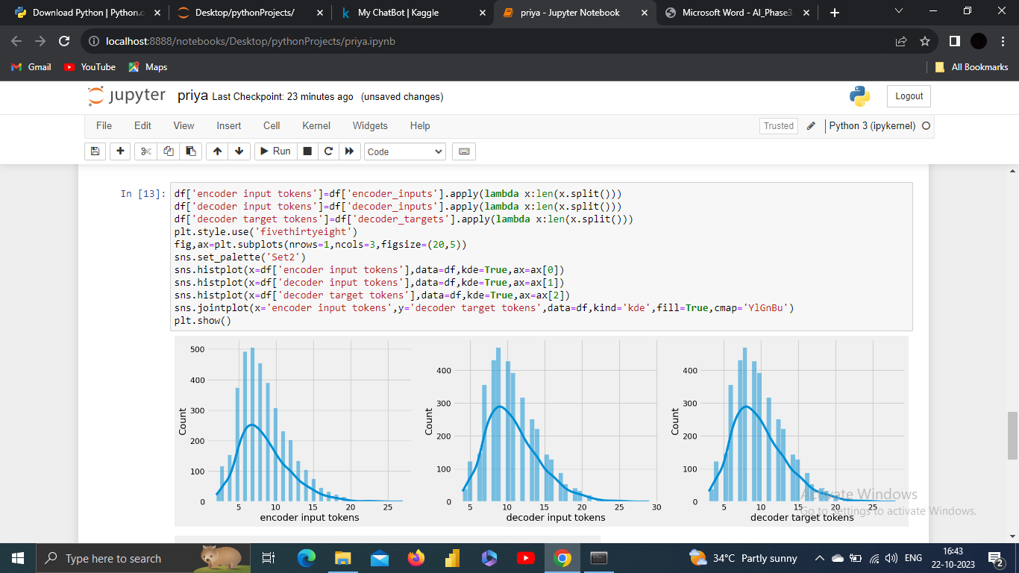

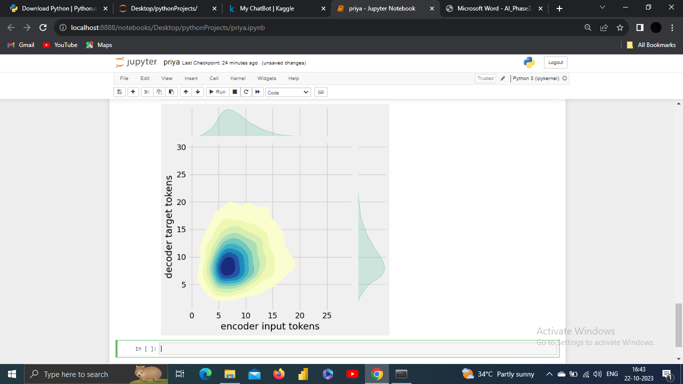

After text preprocessing in the context of chatbot development, the text data is in a cleaner and more structured format, ready for further analysis, understanding, and use in natural language processing (NLP) tasks.

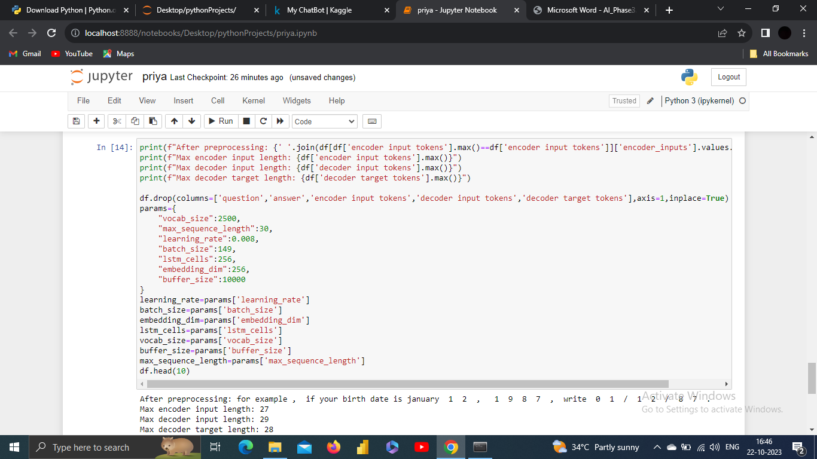 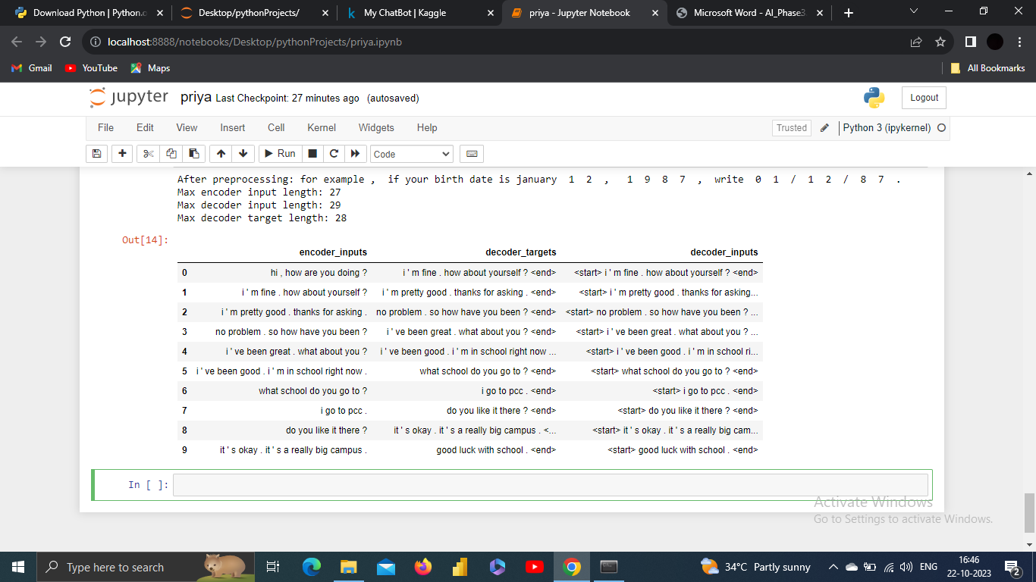

**7. Tokenization**:

Tokenization is the process of splitting a text or a sequence of characters into individual units, known as tokens. These tokens are typically words, phrases, or other meaningful elements. Tokenization is a fundamental step in natural language processing (NLP) and is crucial for various text analysis tasks.

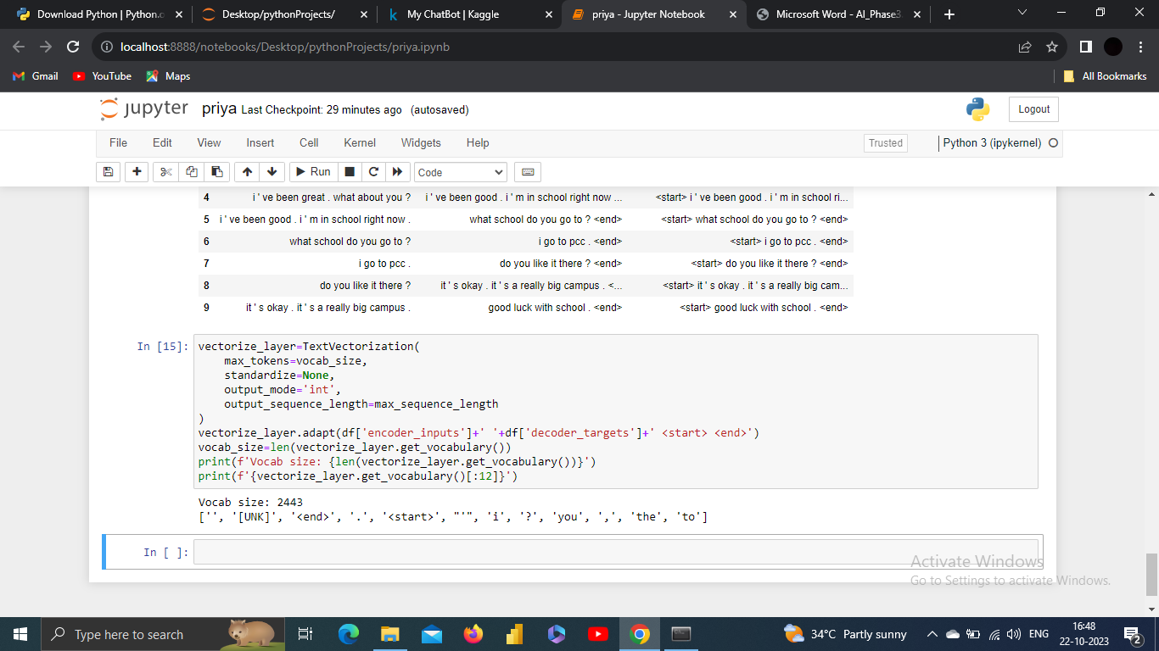

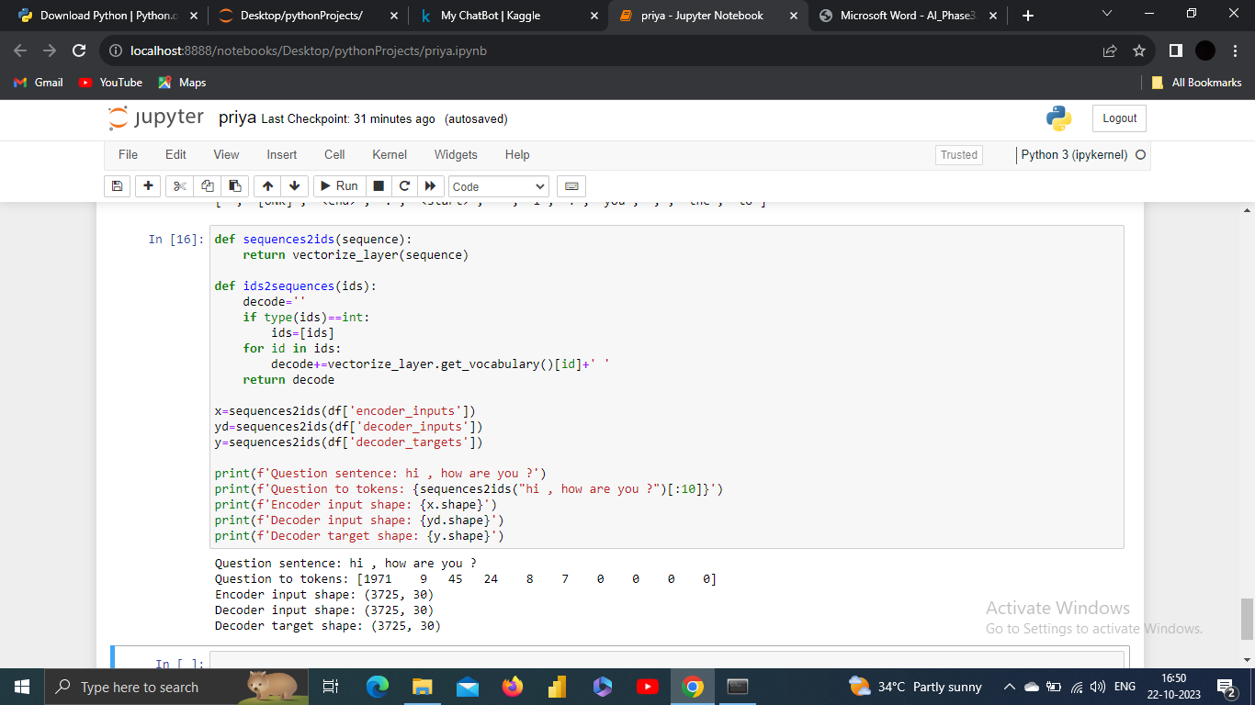

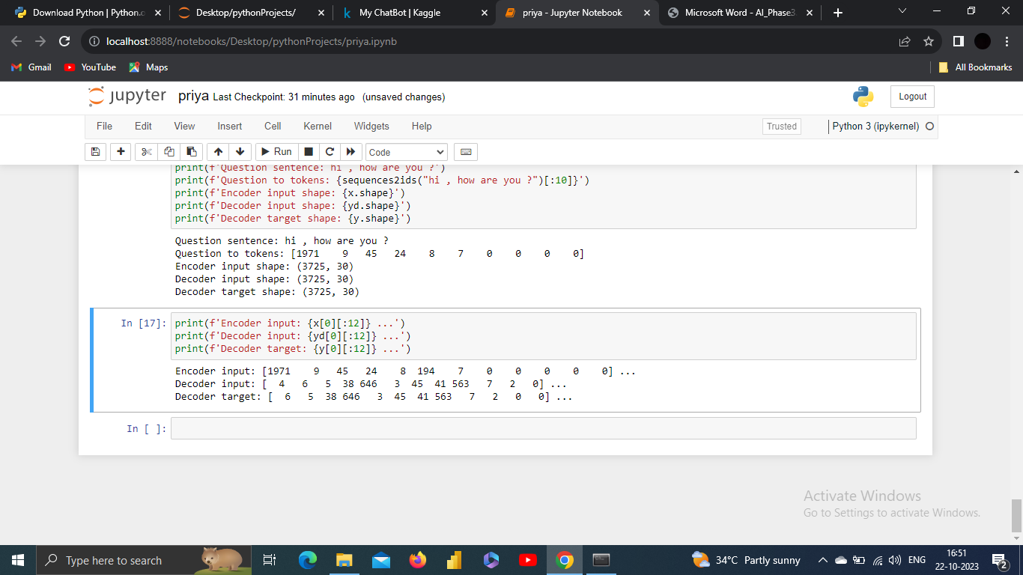

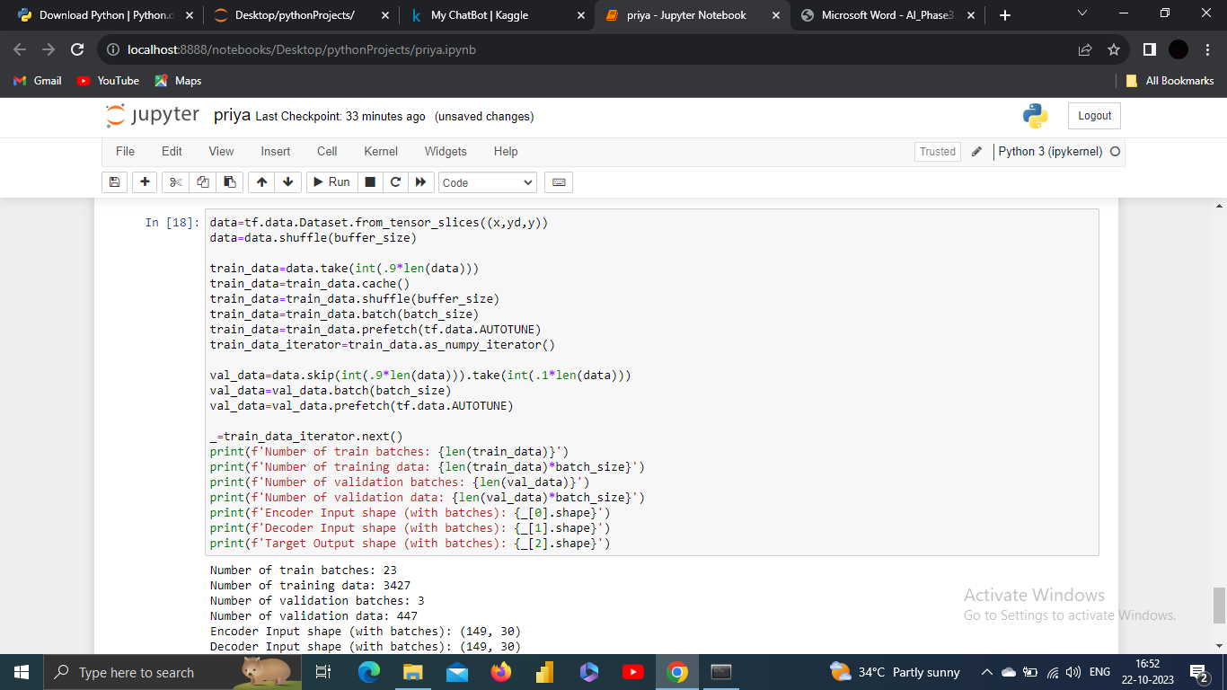

O\P:

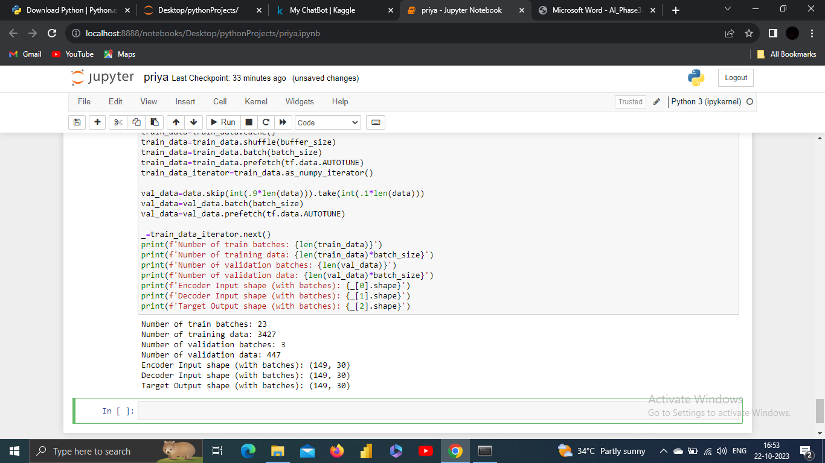

**8. Prototype**:

Build encoder,

To build an encoder, you'll typically be working in the context of deep learning, and this encoder is often associated with autoencoders, recurrent neural networks (RNNs), or other neural network architectures.

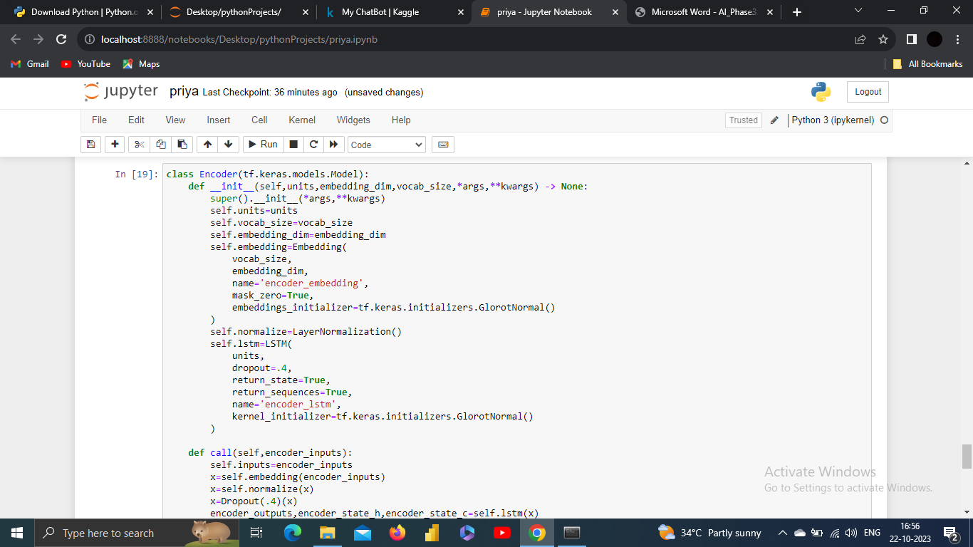

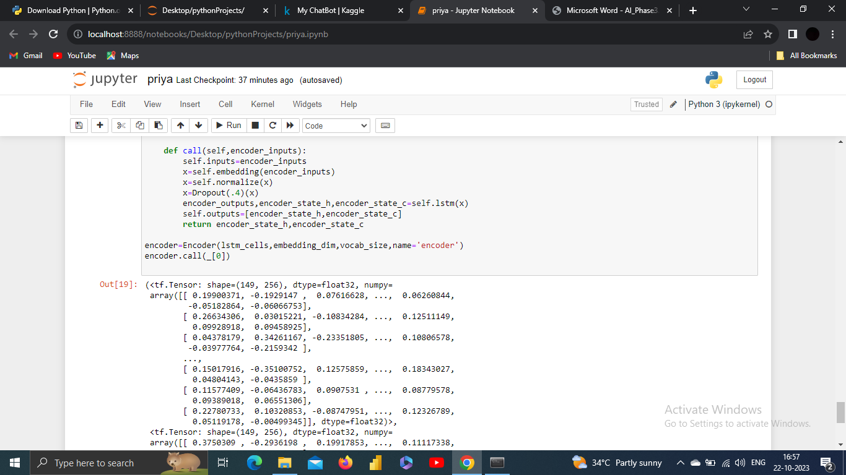

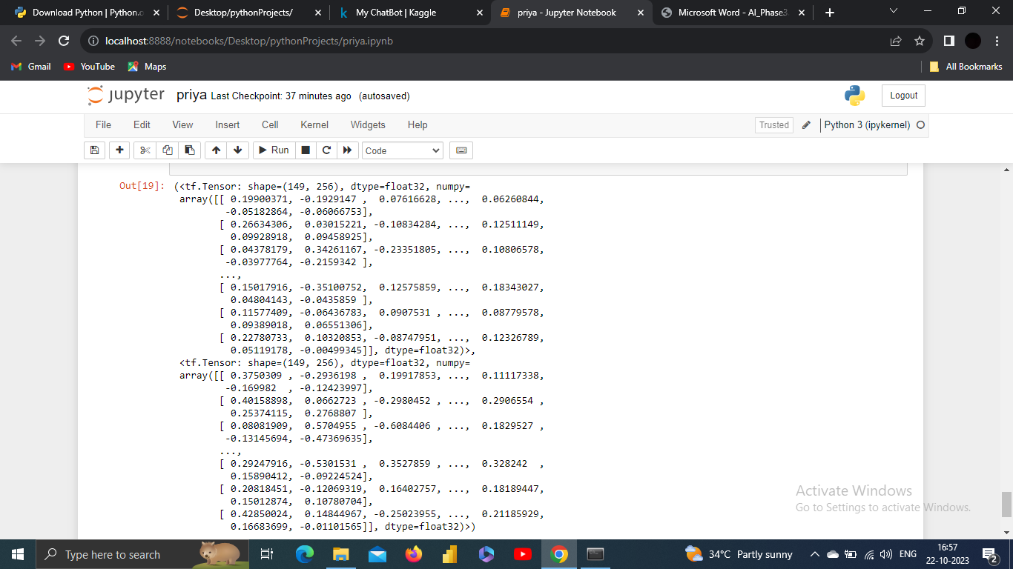

Build Decoder,

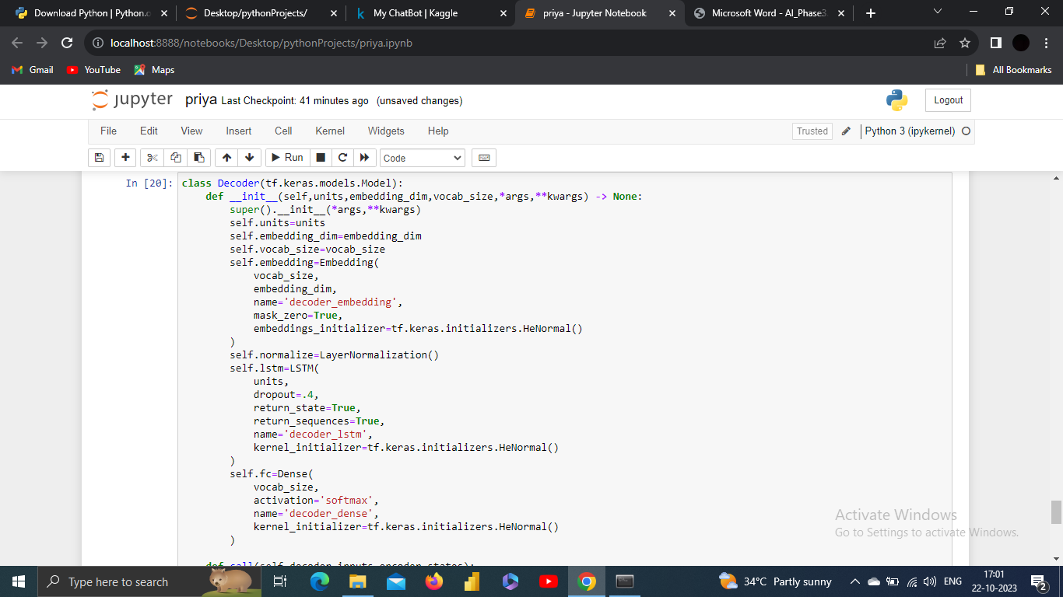

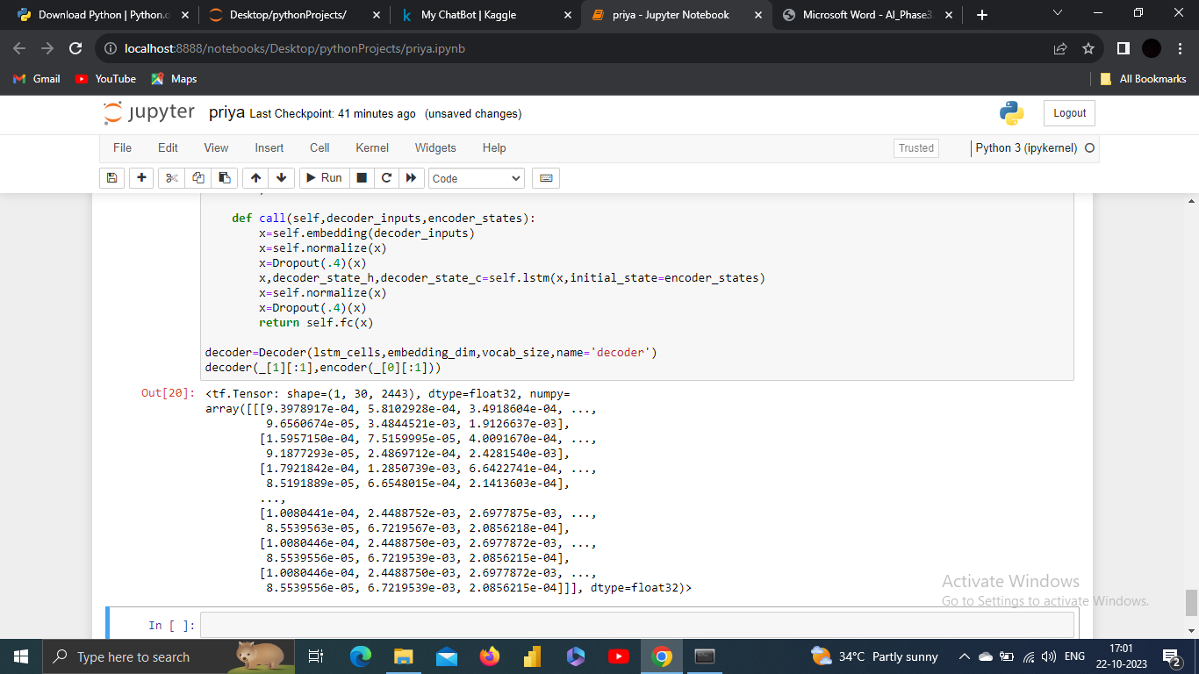

Build Training Model,

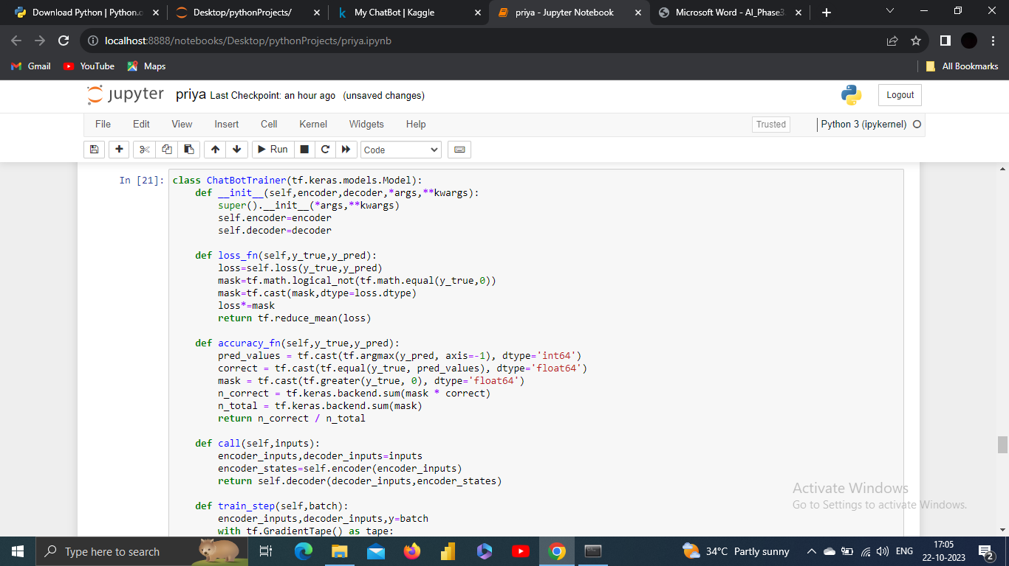

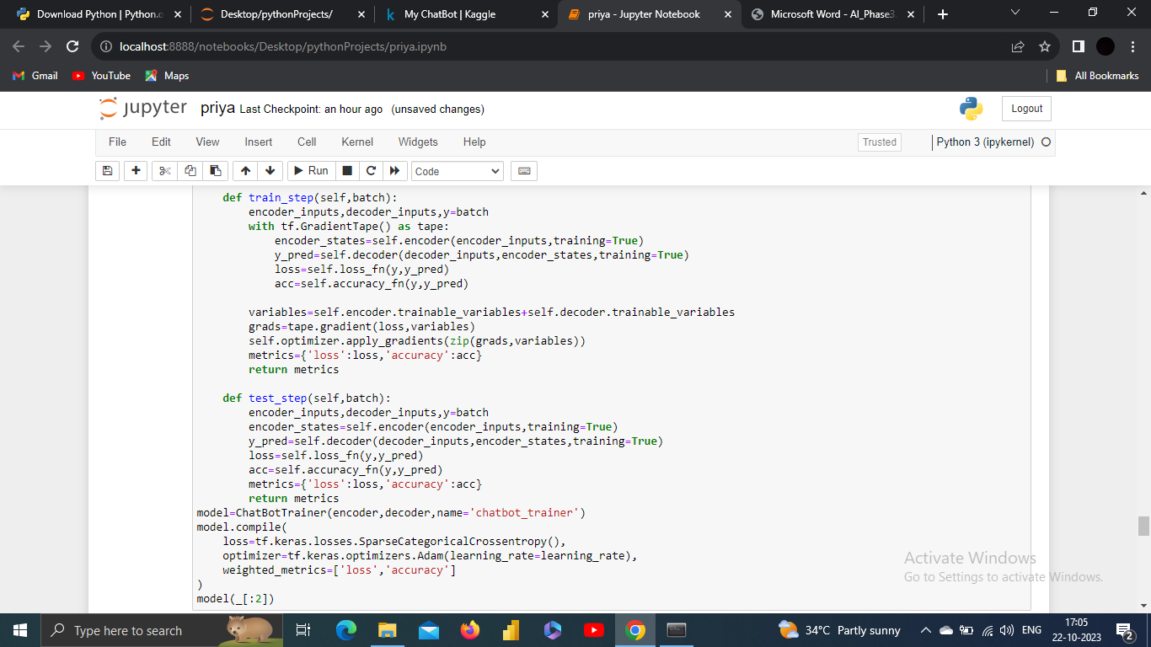

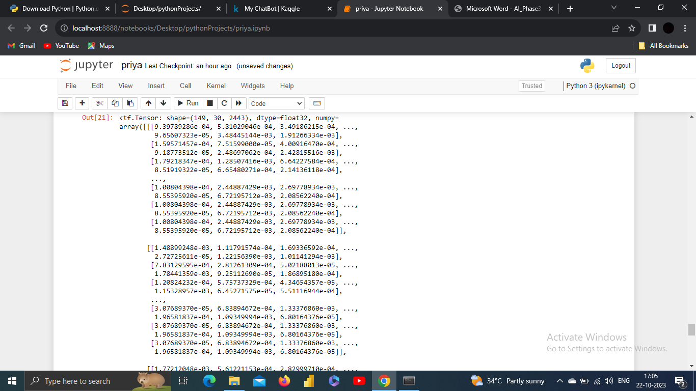

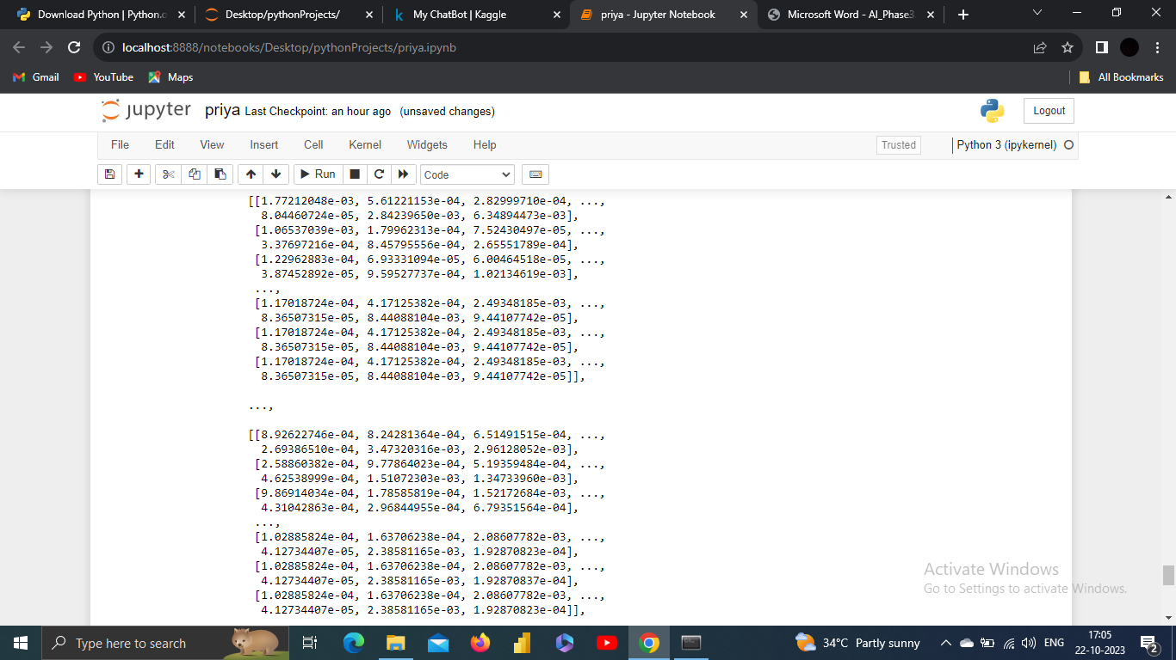

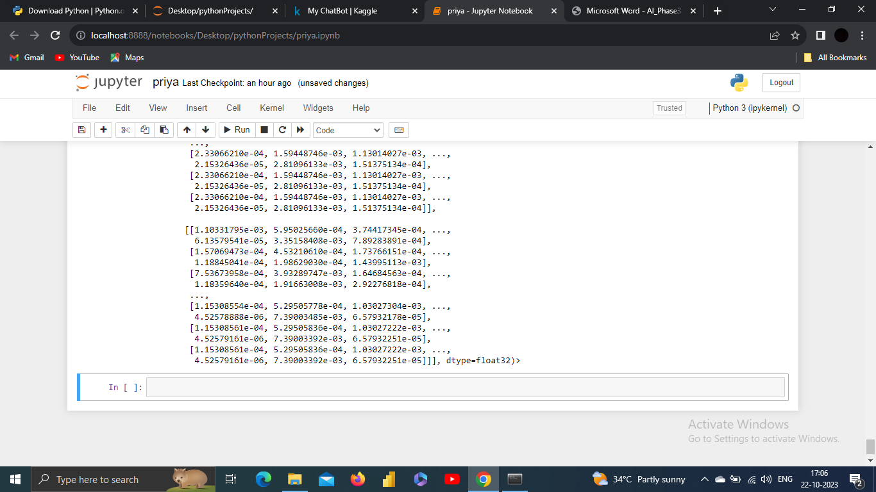

**TRAIN MODEL:**

Training a chatbot model is a crucial step in chatbot development, especially when your chatbot uses natural language processing (NLP) techniques.

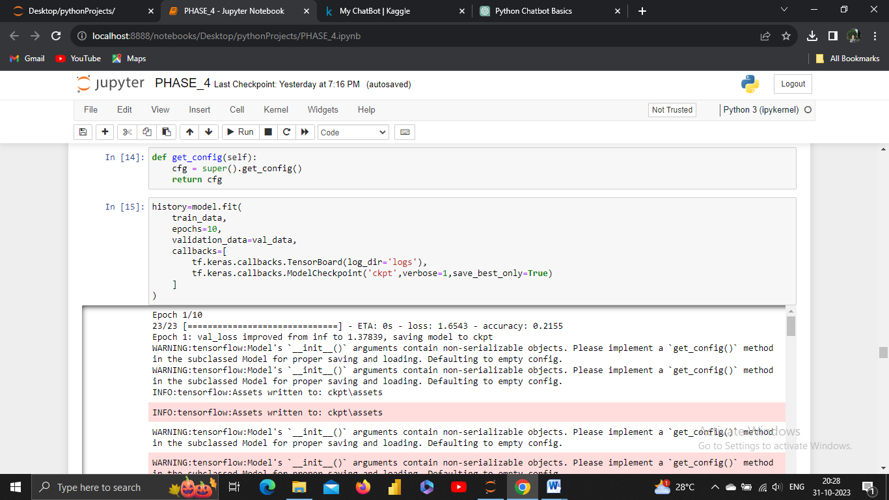

O/P:

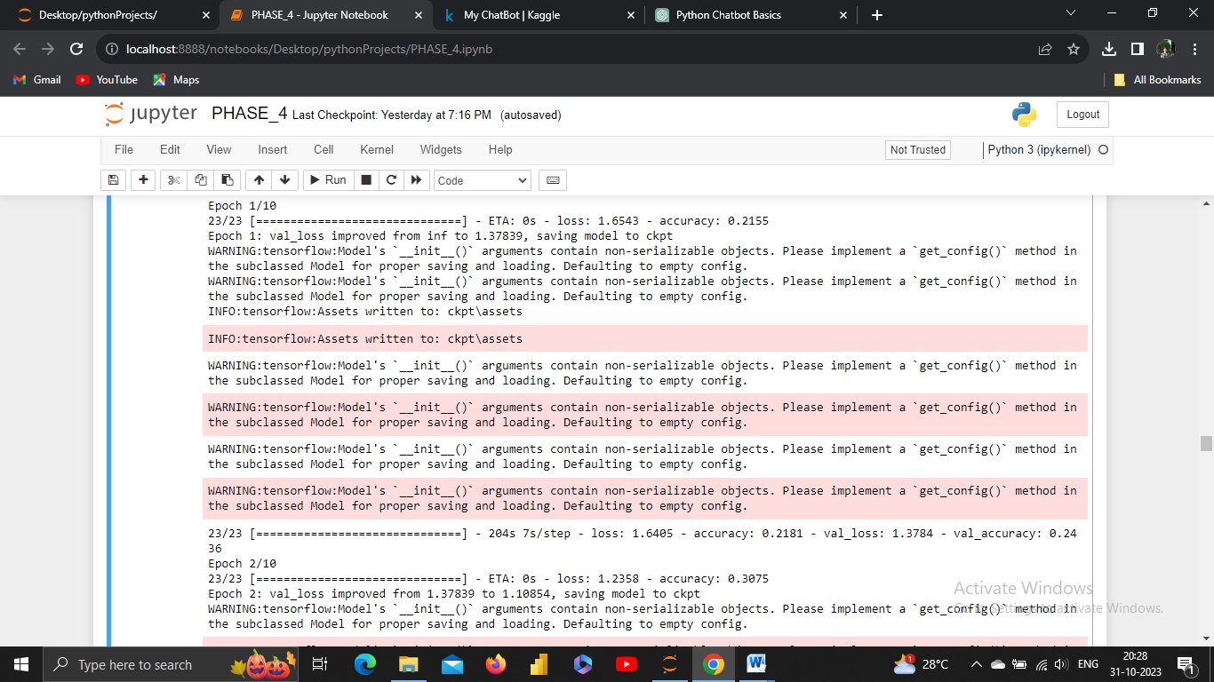

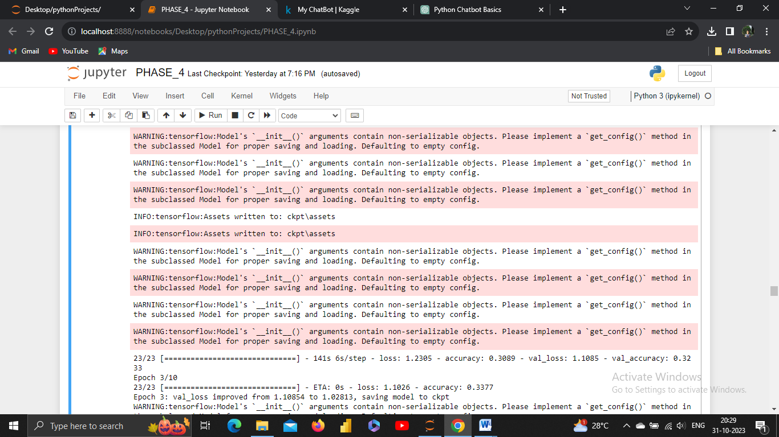

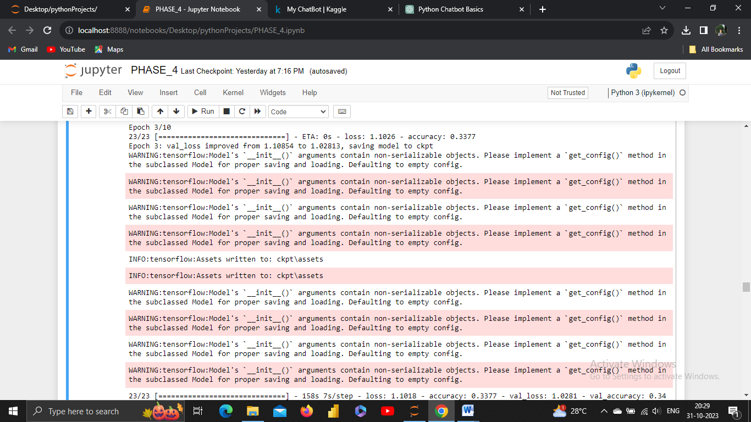

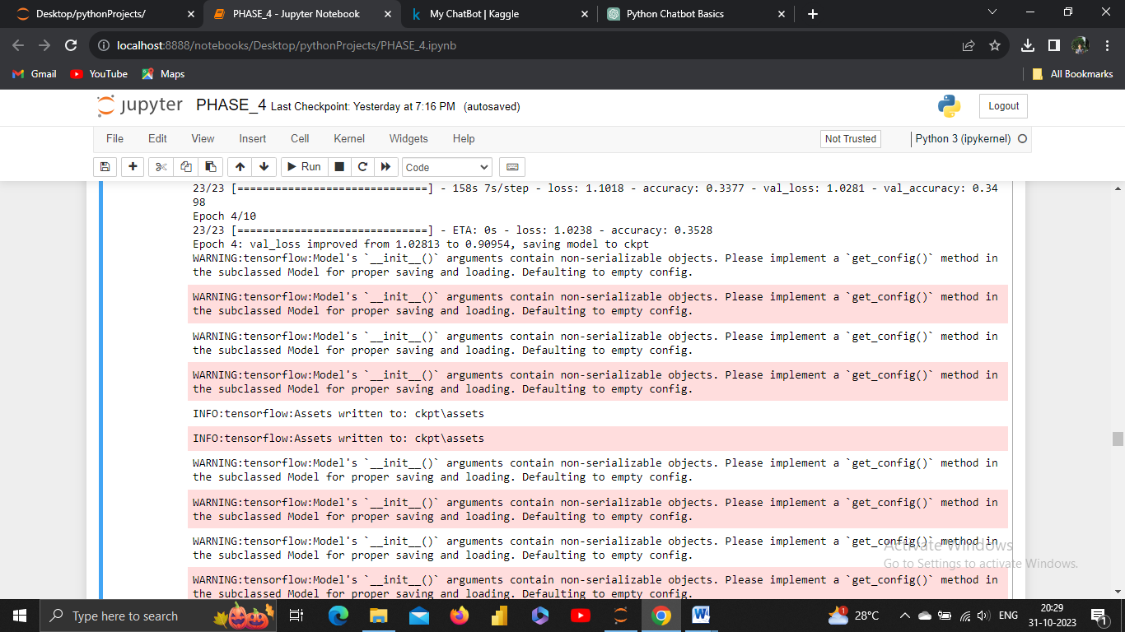

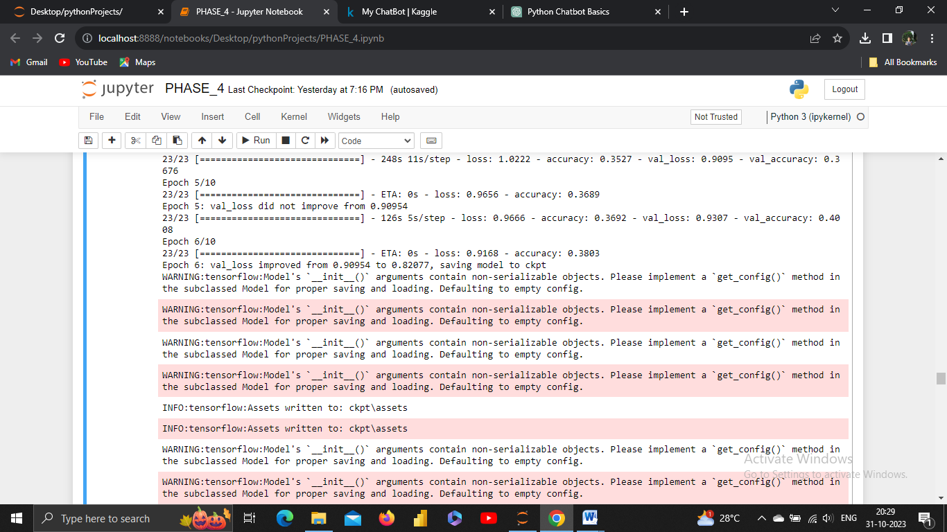

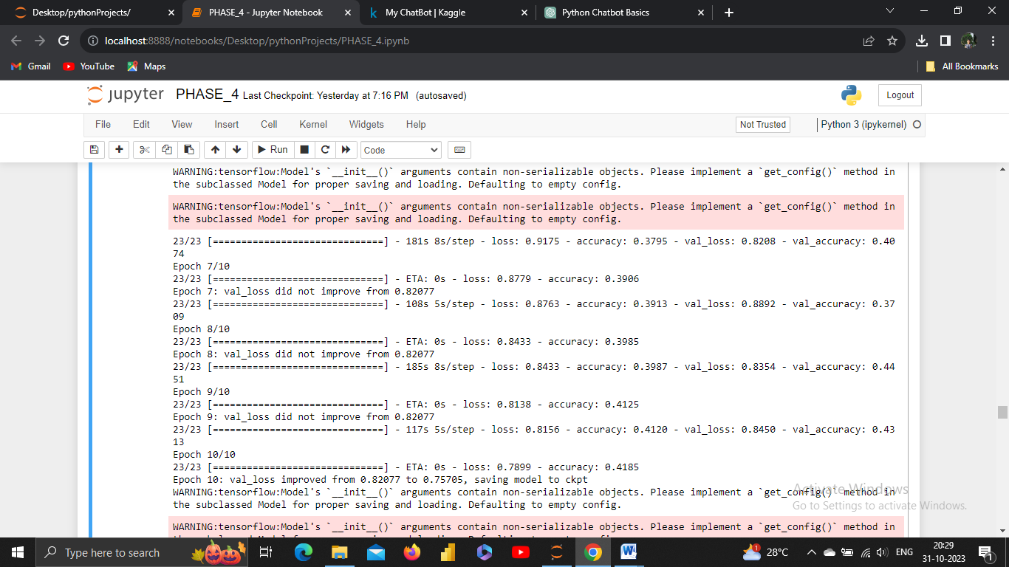

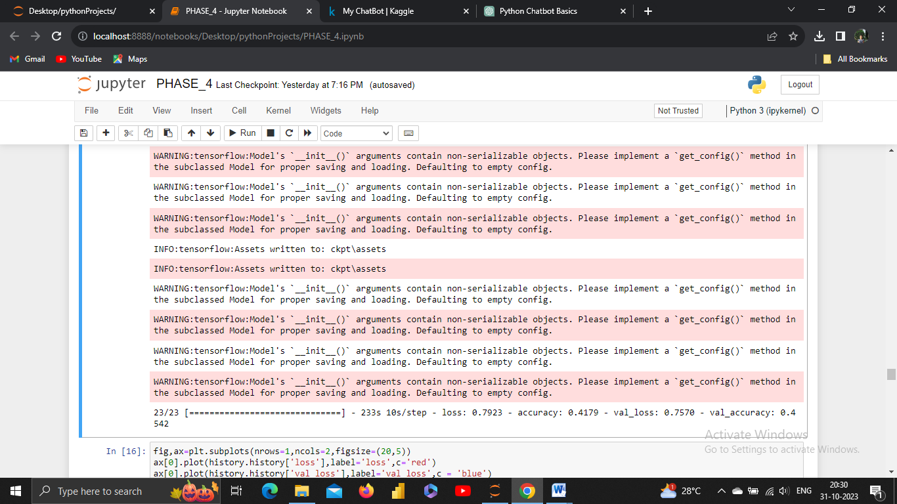

**2.TEST:**

**VISUALIZE METRICS:**

Visualizing metrics is a powerful way to gain insights into the performance of your chatbot or any machine learning model. It allows you to understand how well your model is performing and identify areas for improvement.

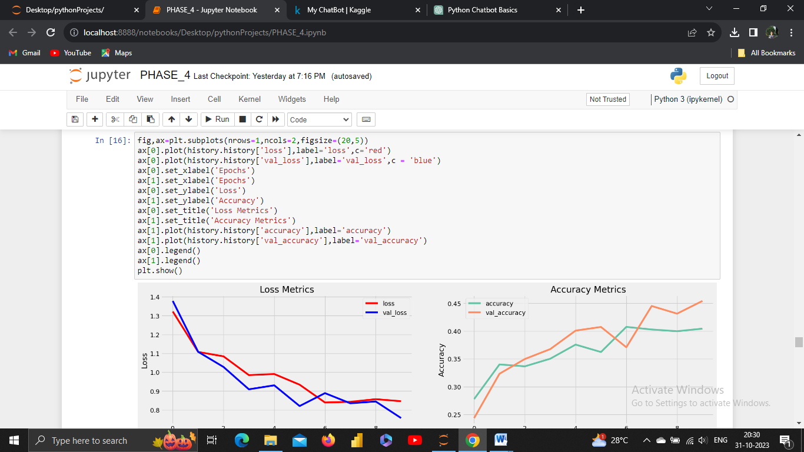

**O/P:**

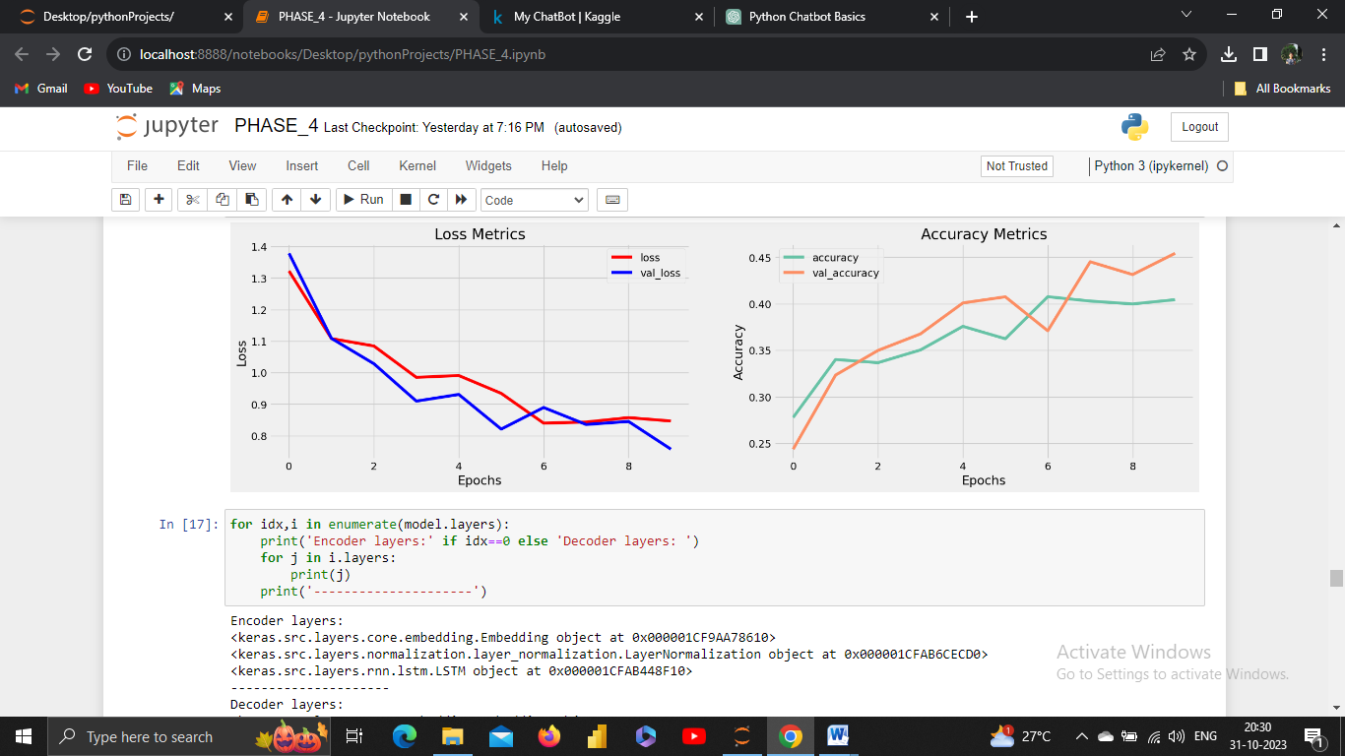

**3.SAVE MODEL:**

Saving a machine learning or chatbot model is essential to preserve the trained model for future use or deployment. In Python, you can save models using libraries like TensorFlow, PyTorch, scikit-learn, or any other machine learning framework.

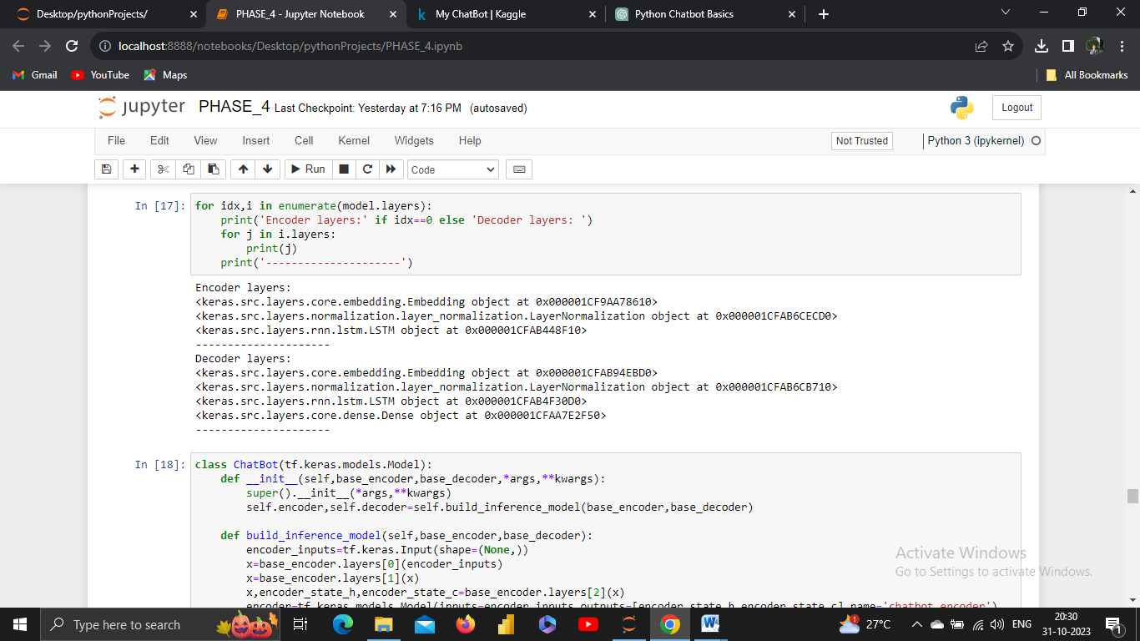

**4.IMPLEMENT:**

To implement a chatbot, you can follow a step-by-step approach, using popular frameworks and libraries for natural language processing (NLP) and machine learning.

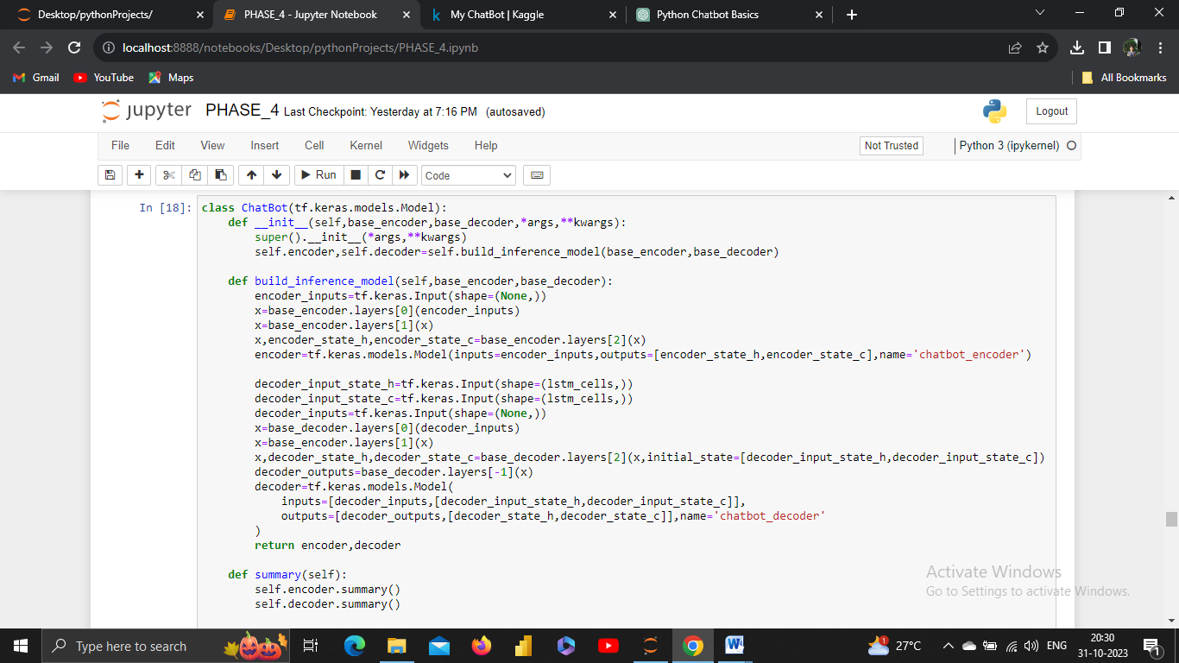

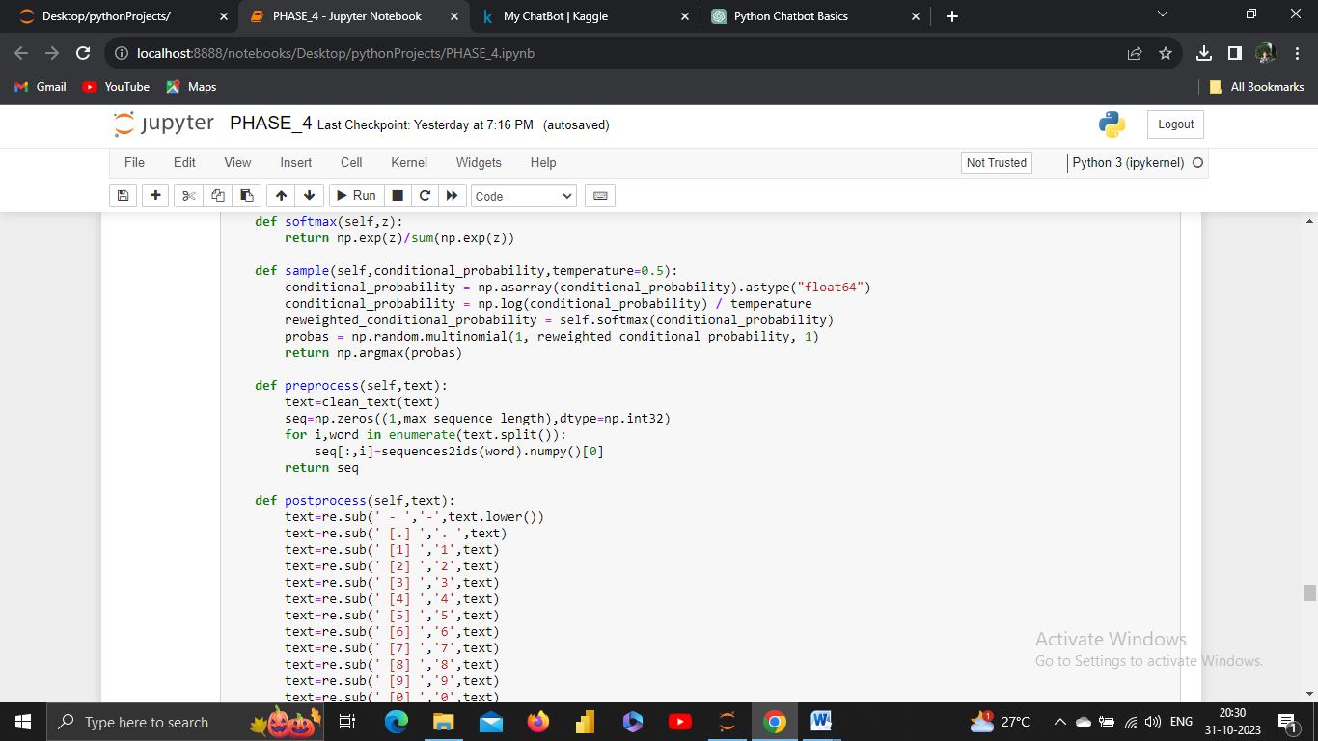

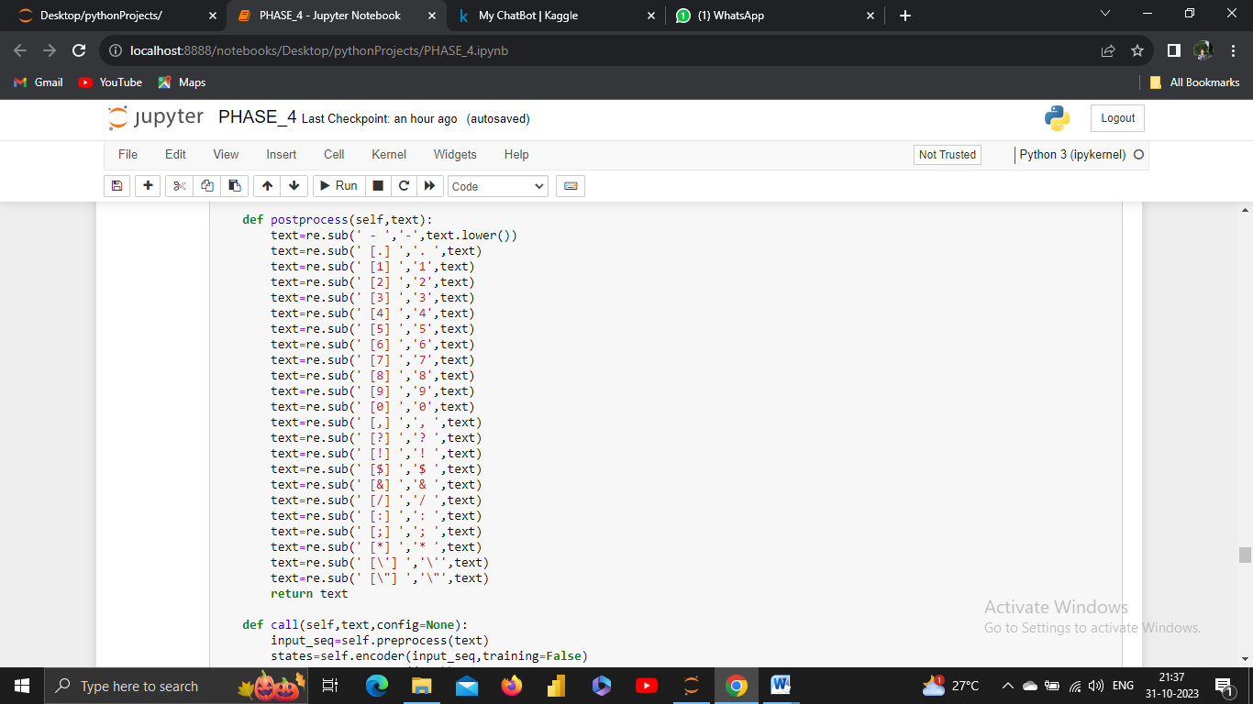

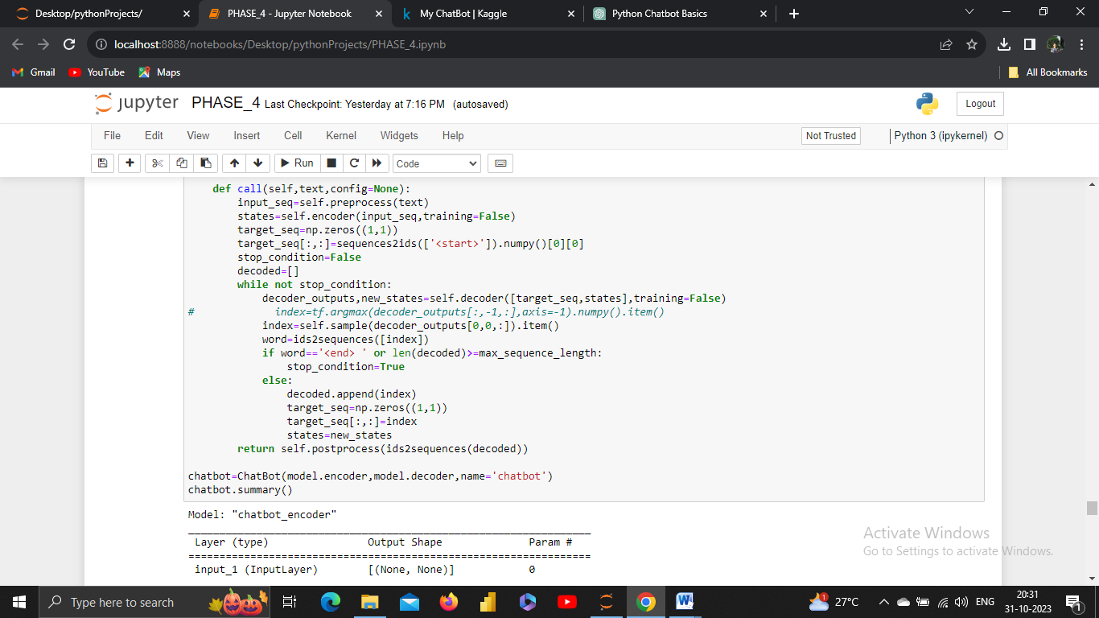

O/P:

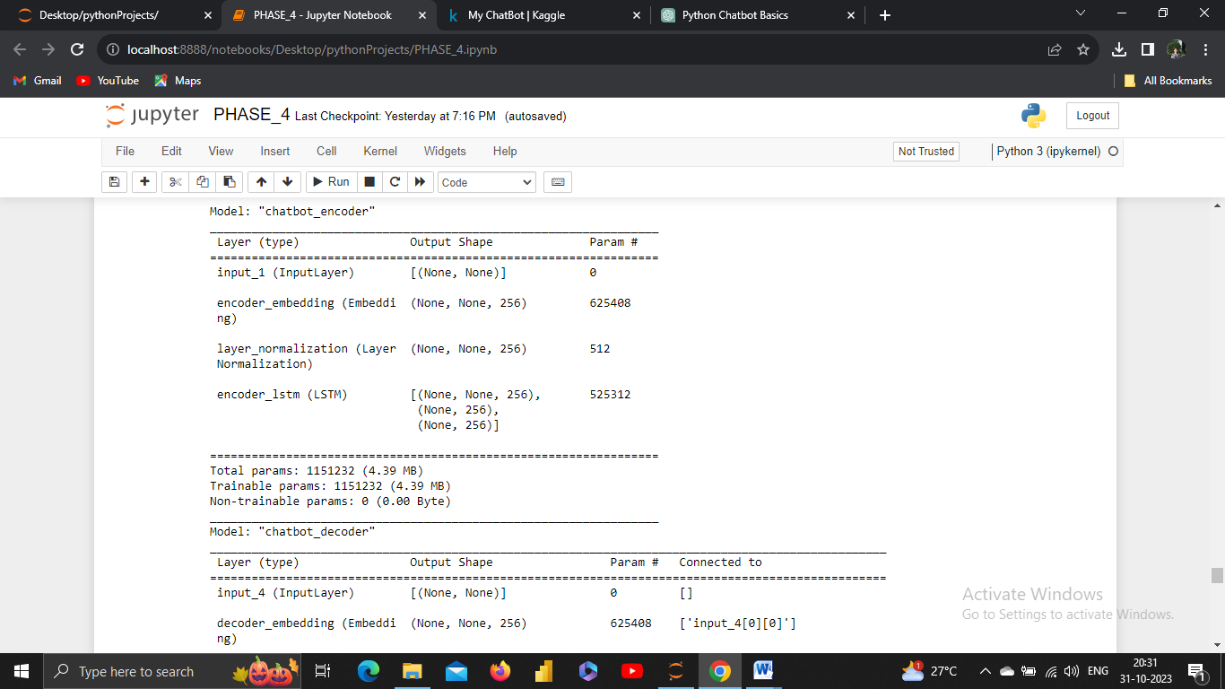

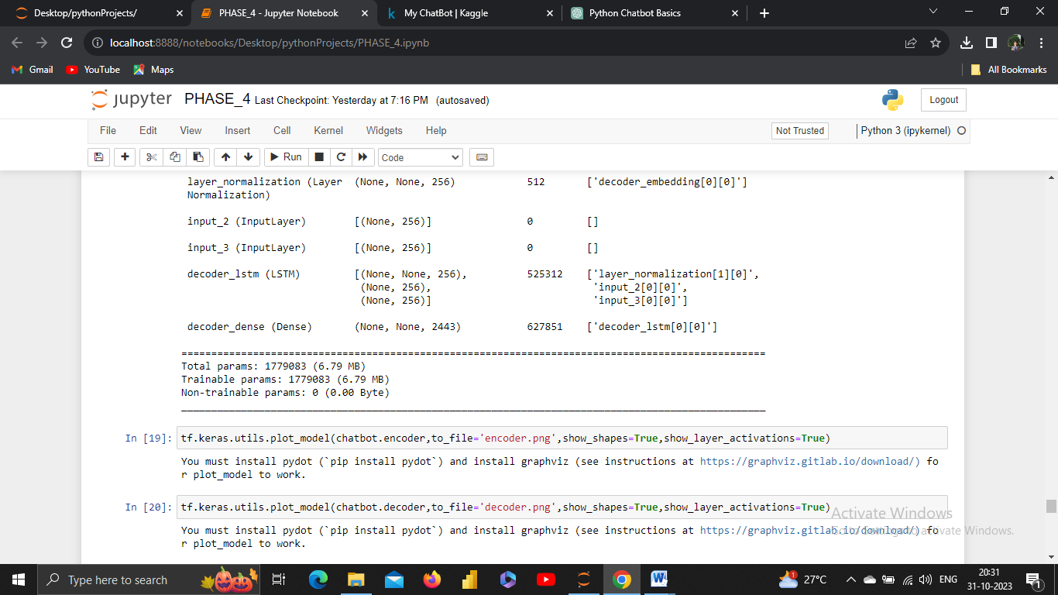**5.DEPLOY:**

**EVALUATION:**

Deploying a chatbot involves making it accessible to users on a specific platform or through a particular channel. The deployment process can vary depending on your chatbot's design and use case.

**TIME TO CHAT:**

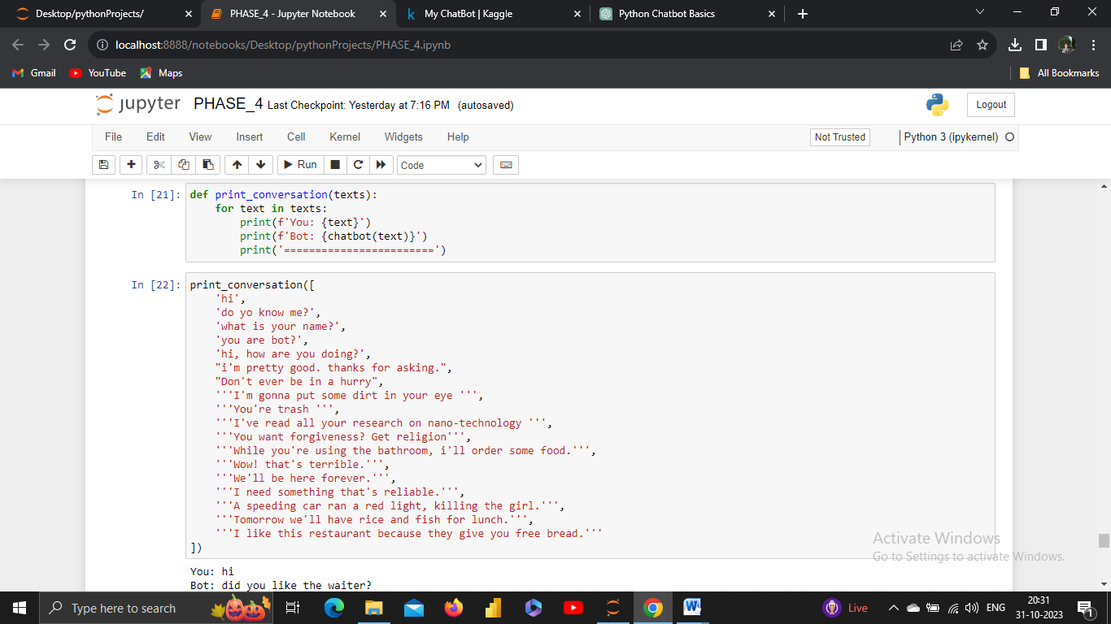

**O/P:**

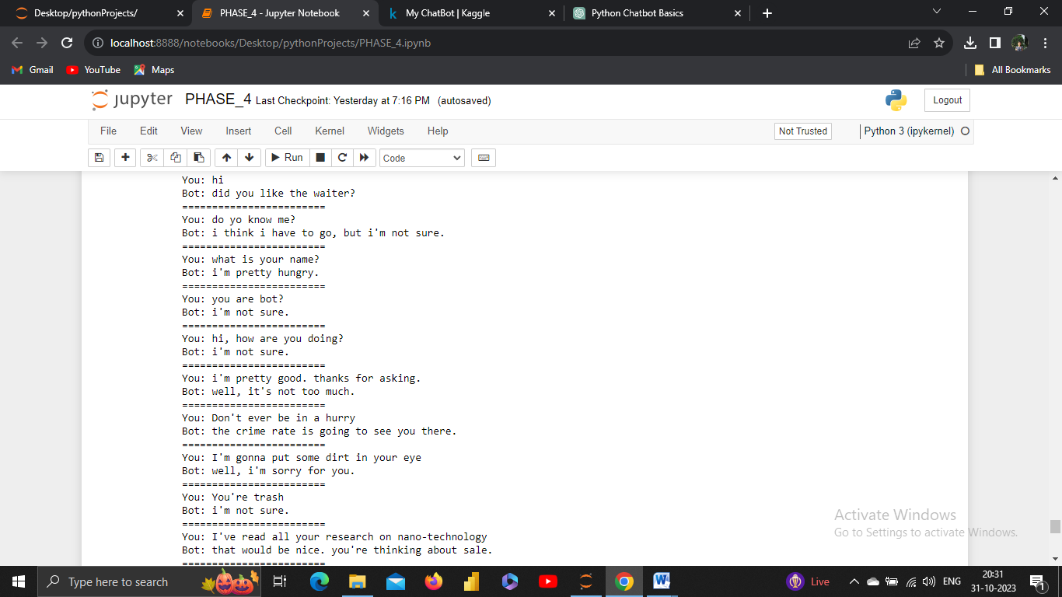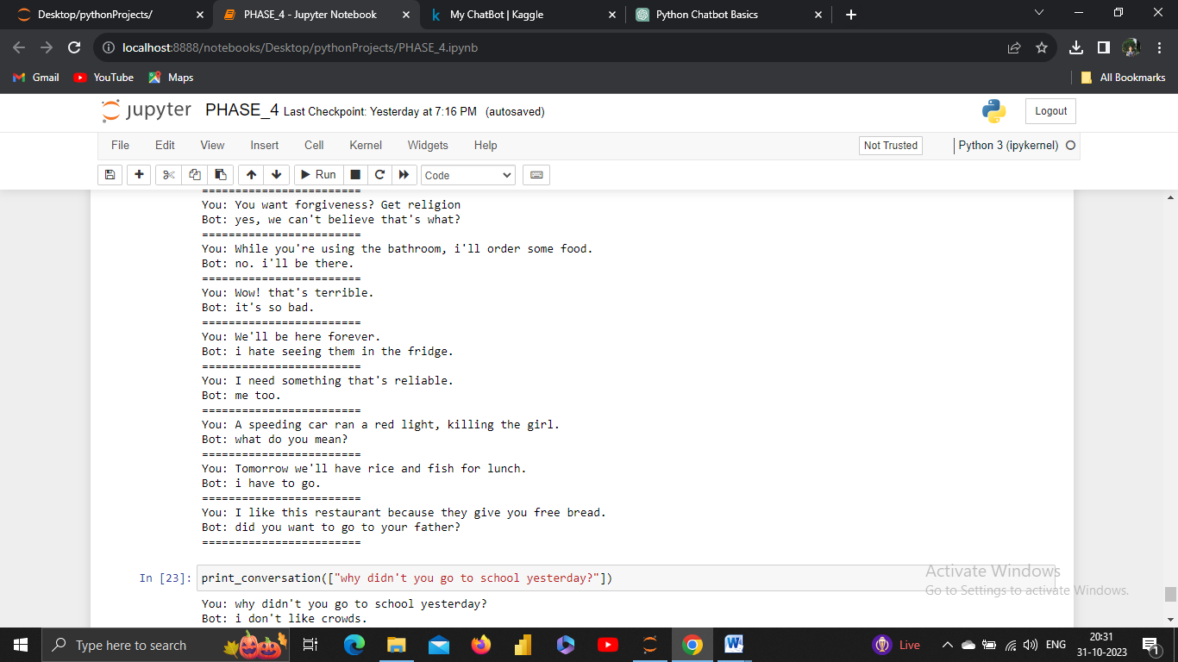

**CONCLUSION:**

In conclusion, chatbot development is a multifaceted process that involves several stages, from design thinking and empathizing with users to deployment and ongoing improvement. It's crucial to follow a structured approach, considering user needs, defining the problem, and applying the principles of design thinking to create a chatbot that delivers real value.

# **POSSIBLE FUTURE WORK:**

There are several exciting and potentially transformative directions for future work on chatbots using Python or other bot development platforms. Here are some possible future avenues for chatbot development and research:

* Multilingual and Cross-Cultural Chatbots: Create chatbots that can understand and respond to users in multiple languages and adapt to cultural nuances. This will make chatbots more inclusive and globally accessible.
* Voice-Enabled Chatbots: Extend chatbot capabilities to support voice interactions, enabling users to have natural conversations without typing. Integrating speech recognition and synthesis technologies will be essential.

These future directions for chatbot development and research hold the potential to significantly enhance the capabilities, usability, and impact of chatbots in various domains and applications. Chatbot developers and researchers can explore these areas to stay at the forefront of conversational AI innovation.

